Automatic Email Sender (LWI)
This document will provide a guide to setting up automatic email sending. This follow the presumption that you have data in a ready state in a notebook prior to this.

Pre-requisites
- Databricks
  - Environment: Data Science (adb-xos-bdp-prod-datascientist)

Local Working Instructions
- Go to Databricks – Data Science Environment (https://adb-3597628874102389.9.azuredatabricks.net/)
- Direct yourself to your notebook
IMPORTANT: Your data should be in a Pyspark dataframe or exported in databricks directory as an Excel File
- After the transformations of your data, input the following code snippets into separate cells:
%run /Workspace/Shared/BI/pipelines/adhoc/email_api/automated_email_sending
message = “[Add your own message]”
send_email_with_attachments OR send_email_no_attachments

Notes:
- %run is a magic command in databricks that executes the called notebook
- The variable message, this can be filtered into HTML or standard text formatting. HTML is preferred due to its formatting style.
- Choose whether you want to send the automatic email sender with or without an attachment
- After you have decided if you want to send the email with or without an attachment you will need to provide the variables attached to the designated function.
  - Send email with attachments (example)
send_email_with_attachments(
access_token=access_token,
from_email='DataAnalytics@80hg.io',
to_email=[‘email_1@address.com’, ‘email_2@address.com’…],
email_subject=’Example Subject’,
content_type="HTML",
content_body=message,
dfs=[dataframe_1],
attachment_names=[‘Dataframe 1’],
file_paths=[excel_path_aq_gwh, excel_path_percent_aq],
attachment_format='xlsx'
)

  - Send email with NO attachments (example)
send_email_no_attachment(
access_token: access token,
from_email: 'DataAnalytics@80hg.io',
to_email: [‘email_1@address.com’, ‘email_2@address.com’…],
email_subject: ‘Example Subject’,
content_type: HTML,
content_body: message
)

Function | Variable Name | Definition/use | Change variable?
send_email_with_attachment | access_token | Obtains access token to send email | NO
 | from_email | Email (DataAnalytics@correla.com) is stored within a group | NO
 | to_email | Able to send singular or multiple recipients | YES
 | email_subject | The title of the email | YES
 | content_type | HTML or Text | YES
 | content_body | Message of the email to the recipients | YES
 | df | PySpark Dataframe (no formatting). This works with attachment name variable) | YES
 | attachment_name | Able to rename the dataframe (df) specified. (This works with df variable) | YES
 | file_paths | If exported from as an excel file for further formatting, use this function by calling the file name or file path (if stored not within the notebooks directory) | YES
 | attachment_format | Currently only XLSX is available | NO
send_email_no_attachment | access_token | Obtains access token to send email | NO
 | from_email | Email (DataAnalytics@correla.com) is stored within a group | NO
 | to_email | Able to send singular or multiple recipients | YES
 | email_subject | The title of the email | YES
 | content_type | HTML or Text | YES
 | content_body | Message of the email to the recipients | YES

- Now you have all the information from above and filled it in, you should be in a place where you are able to test.
- To test it is highly recommended that you only input your email address in the to_email variable part of the function. This avoids cluttering other peoples inbox with test emails of the output.
Please find on the next page an example of each. Any questions or queries, please reach out to Jordan Bignell.

Once you are happy with the email output, you are complete!

Examples

Sending Email with Attachment

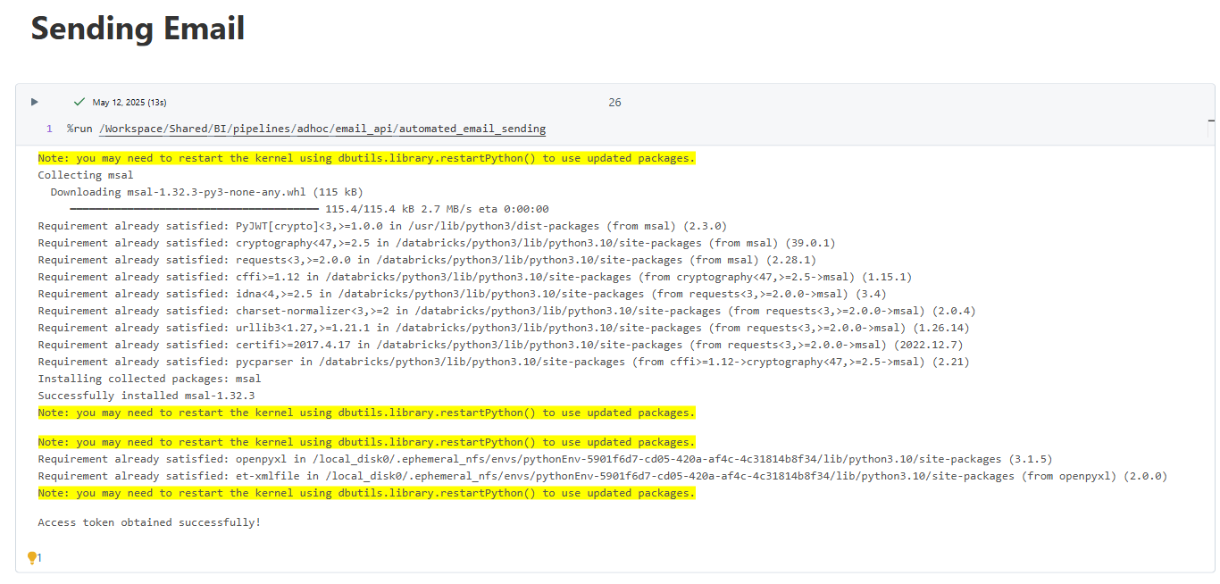

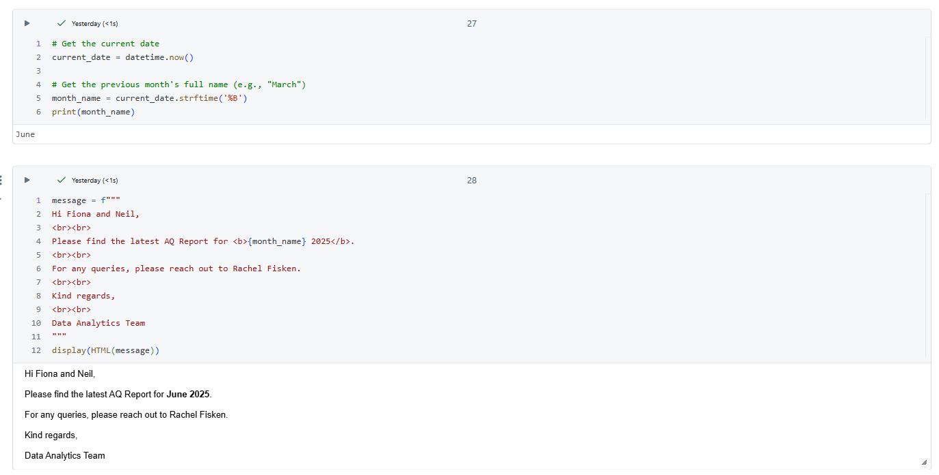

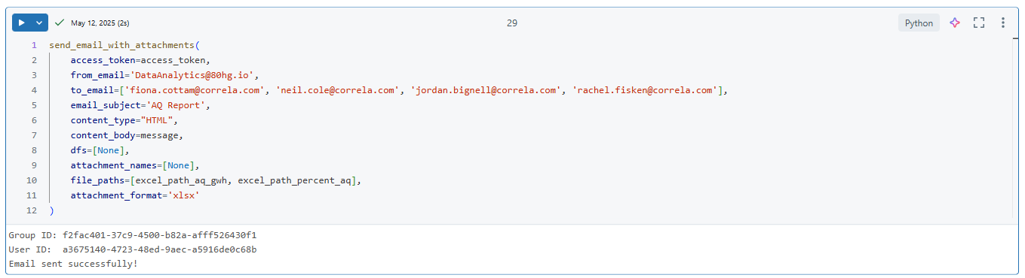

Sending Email with NO attachment
